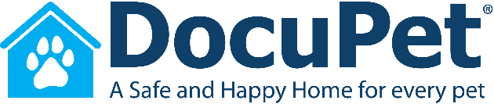

Social Post Content

Below please find some content that you can use to help announce and/or promote Registration on your social media platforms. Additionally, we have added to your “Registration Dropbox” images (Facebook and Instagram format ready) that you can pair with this content.

Please use the custom tracking link provided to your organization in your social posts promoting registration. Please include this link in your post caption or direct followers to the link in your Instagram featured links, so we can track registrations on our end.

Post 1:
📣 Big news for pet parents! We have partnered with @DocuPet to bring the National Pet Registry to our community! Register your pet for free, and enjoy all the free benefits.
✅ ID tag with a unique tracking code
✅ HomeSafe® - 24/7 lost pet service with live support
✅ A detailed online profile that helps get your pet home FAST

Join the movement to keep pets safe—because every pet deserves a way home. 🐾 🏠
Register now: [link]
#DocuPet #PetSafety #HomeSafe #PetReunification

Post 2:
🚨 1 in 3 pets will go missing. Together we can get them home faster.
We’ve partnered with @DocuPet, the National Pet Registry, to give your furry family members the protection they deserve.
When you register your pet, you’ll get a free pet ID tag, access to 24/7 lost pet service with live support, a comprehensive pet profile, and you’ll be part of the most powerful pet registry in North America. 🐾 And did we mention—it’s all free!

💛 Register today: [link]
#NeverLost #DocuPet #LostPetRecovery #PetParents

Post 3:
🐾 Proud to announce our new partnership with @DocuPet—the official National Pet Registry!
Together we’re offering pet parents the most trusted way to protect their pets. The National Pet Registry connects shelters, cities, and owners in a powerful reunification network. When you register your pet for free, you also get all the free benefits:
✨ A tag with custom ID code
✨ Comprehensive pet profile
✨ 24/7 lost pet service with live support
✨ True peace of mind for your whole family
💙 Your pet’s safety is just one click away: [link]
#DocuPet #PetProtection #PartnerForPets #AdoptAndRegister

